**Lesson18 Azure ARM Template**

**Notes:-**

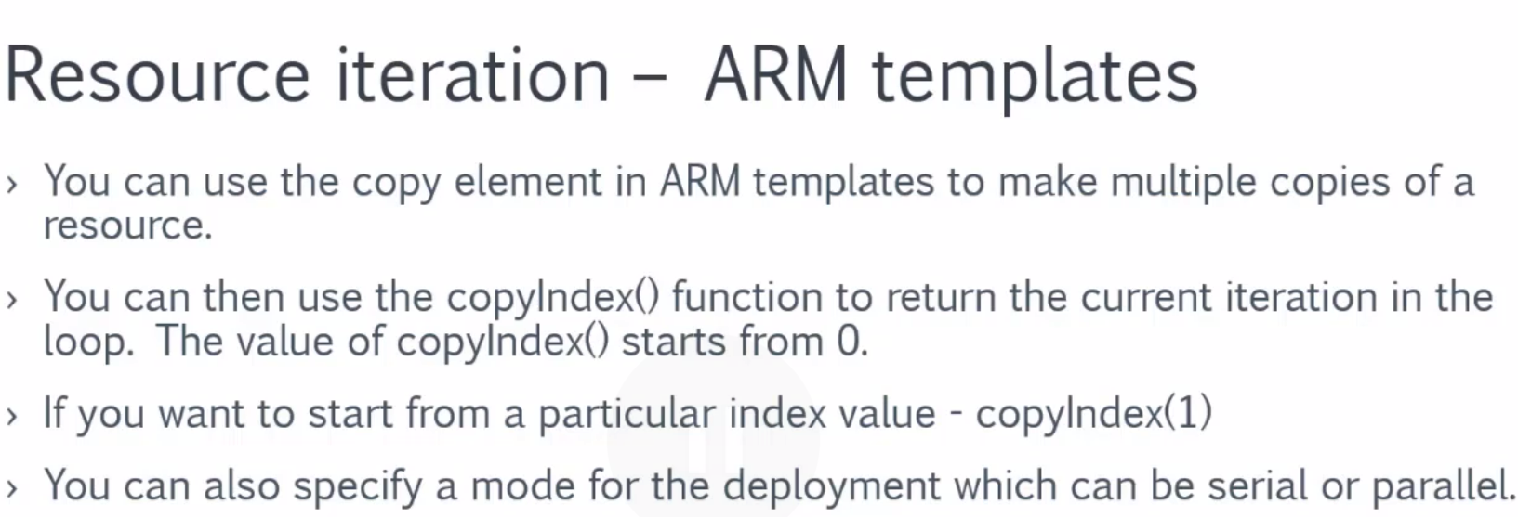

**1-on Azure > create custom template > and set the following template**

**{**

**"$schema": "https://schema.management.azure.com/schemas/2015-01-01/deploymentTemplate.json#",**

**"contentVersion": "1.0.0.0",**

**"parameters": { },**

**"resources": [{**

**//it will naming the resource by concact index with storage with uniqueString**

**"name": "[concat(copyIndex(),'storage',uniqueString(resourceGroup().id))]",**

**"type": "Microsoft.Storage/storageAccounts",**

**"location": "[resourceGroup().location]",**

**"apiVersion": "2019-06-01",**

**"kind": "StorageV2",**

**//set the SKU as standard_LRS**

**"sku": {"name": "Standard_LRS"},**

**"dependsOn": [],**

**"tags": { },**

**"properties": {},**

**//set the instance count of 3**

**"copy":{"name":"storagecopy","count":3,"mode":"Serial","batchSize":1}}]}**